Results for School District Summary:

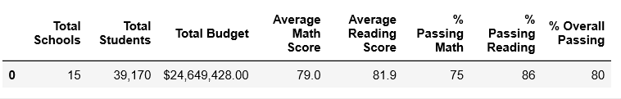

Results for School Summary:

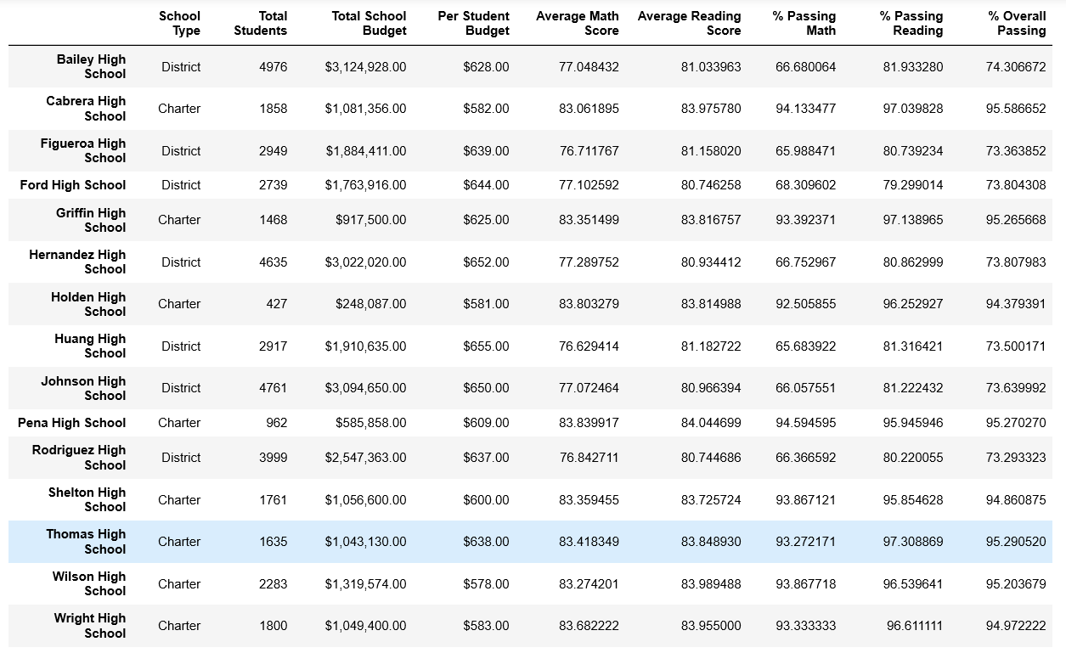

Results for Additional Requirements:

Schools Sorted into Top 5:

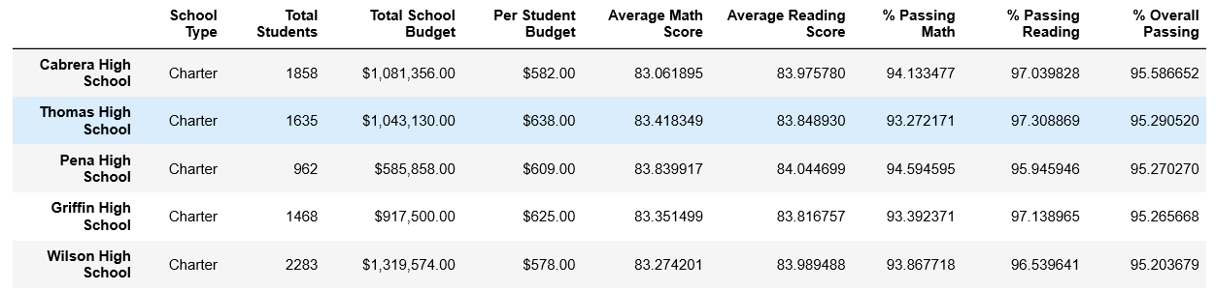

Schools Sorted into Bottom 5:

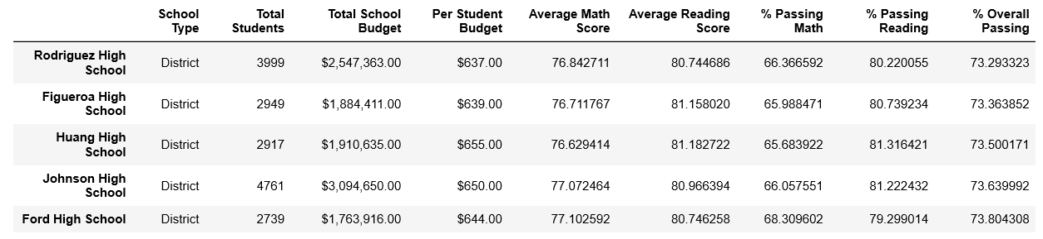

Grouping Scores by Grade:

Math Reading

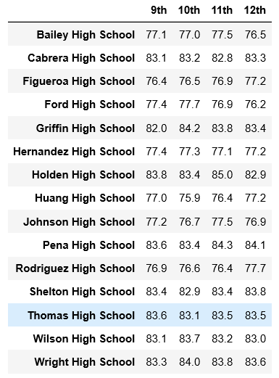 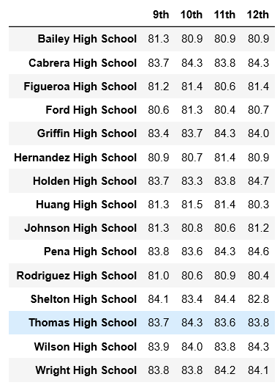

Grouping Scores by School Spending Per Student:

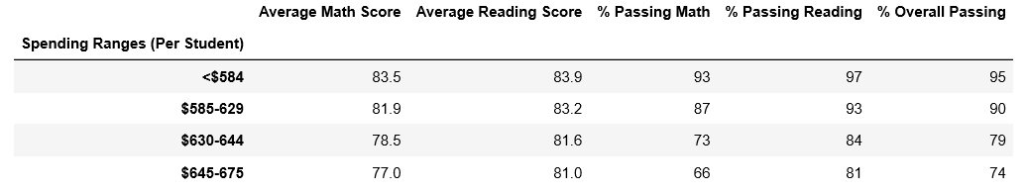

Grouping Schools by Size:

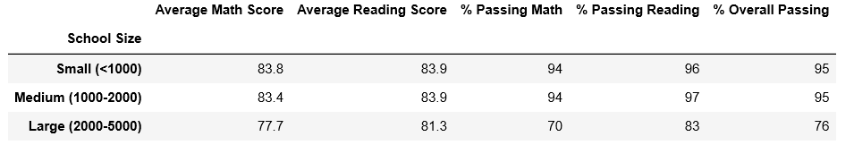

Grouping Schools by Type:

